fc=100;

t=0:0.0005:0.5;

msg=0.5;

fm=25;

w=2\*pi;

%%Message Signal

xm= msg\*cos(w\*fm\*t);

subplot(4,1,1);

plot(t,xm);

title('Message Signal');

%%Carrier wave

xc= cos(w\*fc\*t);

subplot(4,1,2);

plot(t,xc);

title('Carrier Signal');

%% Frequency Modulated Waveform

kf=1;

a=(msg\*sin(w\*fm\*t))/w\*fm;

C= cos(w\*fc\*t+a\*kf);

subplot(4,1,3)

plot(t,C);

title ('Frequency Modulated Output');

%% Phase Modulated Waveform

kp=pi;

C= cos(w\*fc\*t+xm\*kp) ;

subplot(4,1,4)

plot(t,C);

title ('Phase Modulated Output');

A close up of a device

Description generated with very high confidence

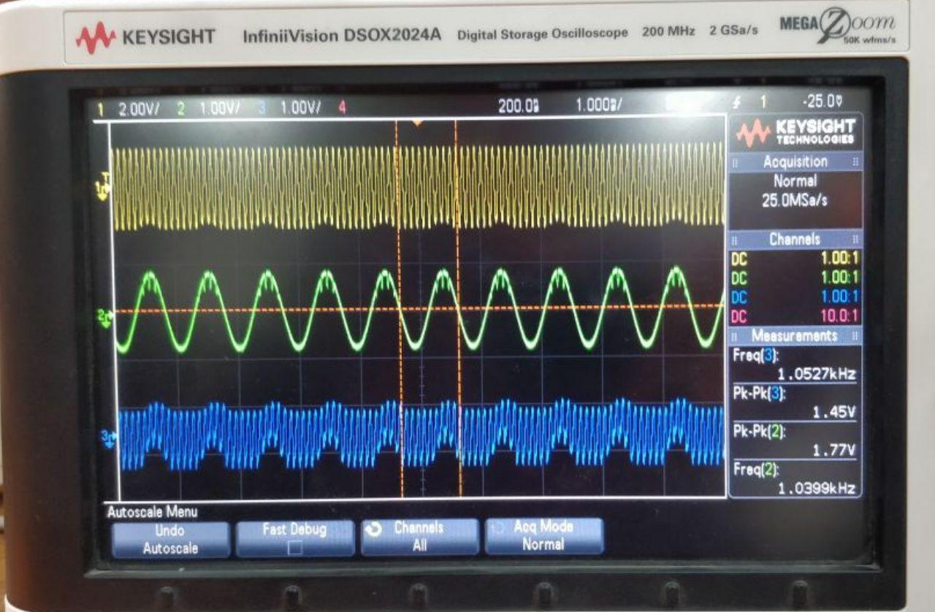

A close up of a computer screen

Description generated with very high confidence